IDENTIFICATION OF MEDICAL PLANTS

Dr.R.Karthiga Electronics and Computer Engineering
SRM Institute of Science and Technology Chennai, India

Kunderu Lokesh Electronics and Computer Engineering
SRM Institute of Science and Technology Chennai, India kl2803@srmist.edu.in
Shaik Sahil
Electrronics and Computer Engineering
SRM Institute of Science andTechnology Chennai, India ss0829@srmist.edu.in

Dharnish Barath S R
Electronics and Computer Engineering SRM Institiute of Science and Technology Chennai,India
ds1860@srmist.edu.in

Abstract— The project exploits the power of computer vision and ML for addressing an urgent need in the realm of herbal medicine and biodiversity conservation. Medicinal plants have been used in traditional medicine for thousands of years, thus there is an overarching need for preserving and accurately identifying these plants from health and environmental standpoints. For this objective, a comprehensive dataset of high-quality images of plants shall be generated, and under that dataset, a number of species shall be considered, which are known to have medicinal use. Deep learning techniques such as CNN shall identify meaningful features from these images while classifying them into the pertinent plant categories. This research project aims to design a robust and efficient image classification system capable of identifying various medicinal plants from images of leaves, flowers, and other botanical features. "Identifying Medicinal Plants through Image Classification" fills the gap between traditional ayurvedic knowledge and modern technology. It has employed the competence of image classification and machine learning for promoting sustainable exploitation of medicinal plants, thus developing an understanding of ayurvedic healing capabilities.

Keywords-
Image Processing,Artificial Intelligence, Convolutional Neural Networks

INTRODUCTION
One of the most ancient systems of medicine in which practice was seen in India is Ayurveda, which dates back to Vedic times .i.e approximately 5000 years ago. The chief constituents of ayurvedic medicines are leaves and other parts of the plant like root, bark etc. Over 8000 Indian plants have been known to have medicinal values.
Around 1500 of these are used in various Indian systems of Herbal medicines. Commercial Ayurvedic medicine or product preparations use around
500 of these plants. And also 80% of plants used in ayurvedic formulations are collected from forests and wastelands whereas the remaining are cultivated in agricultural farms. In the ancient times, Ayurvedic physicians themselves picked the medicinal plants and prepared the medicines for their patients. Leaves are the major deciding factor for identification of medicinal plants. All the steps to classify the leaf of a plant are capturing image, removing noise and resizing, extracting features, using proposed methodology, and finally identifying or recognizing the plant.

LITERATURE SURVEY
We made a detailed literature survey by going through the existing systems that detect fake and clone accounts. For the preparation of this survey, we have referred the following research papers, journals, and publications.
Researchers tried several methods to derive the characteristics and identify classify the species of plants. Most of these approaches utilize different parameters such as color, shape, and texture features to combine. Unlike some studies on leaves or plant foliage, only few of the primary studies identify species based solely on flowers.
In conclusion, the literature survey is considered a basis for our research itself in identification of medicinal plants. It provides us with a general understanding of current methodologies, challenges, and potential avenues for improvement through this synthesis of insights of diverse studies.
The findings and perspectives in this survey have been guiding us in forming research objectives and methodologies that can make useful contributions to this developing field.

EXISTING SYSTEM
Researchers have attempted many strategies to derive the traits and to identify, classify the species of plant.Some studies did not only focus on the plant but also on the whole flower region and also on parts of the flower
.
Hsu et al. analyzed color and structure not only of the whole flower but also the pistil area. Authors proposed studying the lip (labellum) region of orchid species. This proposes features, which capture color, texture, and form (shape) of petals, in addition to their arrangement. Which we can also analyze and use to identify the species, color, and shape of any particular plant leaf.
Arun Priya et al. compared SVM with k-NN classification which was based on the shape and vein features and noticed that SVM with 94.5% outperformed k-NN with only 78%.
Abdul Kadir et.al proposed a method to identify the plants and many features such as texture, vein, shape and color of the leaves are extracted.
Vijayashree introduced a method called Computer-Aided Plant Species Identification Technique (CAPSI), Is primarily based on the image matching technique of leaf shape. Different biometric features like width factor, diameter, minor axis, major axis, perimeter, area and the aspect ratio of the leaf image are extracted. An artificial neural network (ANN) classifier is used for the classification of leaf mages.
Pavan et al proposed an algorithm for identification using a multiclass classification which is based on the color, shape,volume and cell feature. They performed three-stage comparisons: the first stage compares redness, greenness, blueness index feature, the second stage compares shape feature and the last stage compares cell feature and volume fraction feature. The experiment is performed on a A sample of a various collection of one thousand leaf and flower and flower images.

PROPOSED SYSTEM
TensorFlow and Keras api are used in the Image Processing process to create a useful tool that helps users identify medicinal plants in the wild.
Uses JavaScript to quickly and briefly provide information about the plant's online availability.It is a javascript tool that assists users in cities by providing
them with the addresses of government-approved areas where these plants can be found.
Depending on the user's past medical history saved in the database, which is constructed using Postgres, it offers customized plant recommendations for treatments along with what to avoid.The next stages will include the implementation of the suggested system:
Phase 1: Data Collection: Obtaining a large dataset of excellent photos of different medicinal plants is the goal of the data collection stage. The images will be collected from sources like government databases,gardens, and
nurseries.

Phase 2: Data preprocessing: In this phase, the pictures will be resized, cropped, and normalized. To quickly and significantly enhance the CNN model's performance, this step is crucial. Specifically, the OS library and OpenCV are used to accomplish this process. After that, the data is randomly divided into three sections: 70% for the training phase, 20% for the validation phase, and 10% for the testing phase.
Phase 3: Model training:A CNN model will be trained using the preprocessed dataset during the model training phase. The model will undergo training in order to identify relevant characteristics from the photos and categorize the plants into distinct groups. TensorFlow libraries and Keras are used for the training phase.
Phase 4: Model evaluation: To gauge the performance of the trained model, a held-out test set will be used. If more optimisation is required, the model will be refined.
Phase 5: Mobile application development: This is the last phase, during which the mobile application will be developed. This stage involves converting the code into TensorFlow light and deploying it into an application that we're building with Flutter. We also intend to add more revolutionary features like providing information on government-approved ayurvedic plant centres, plant recommendations based on their medicinal properties, and more.

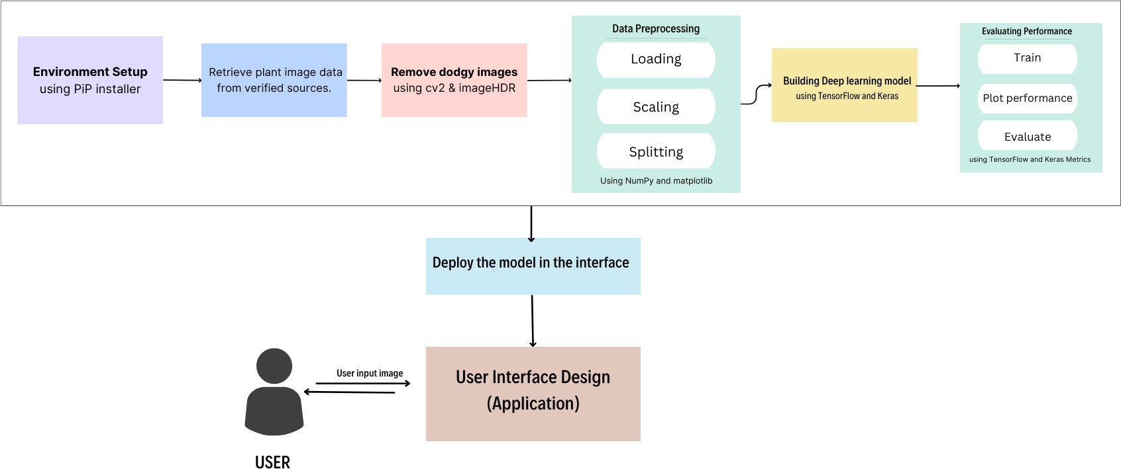

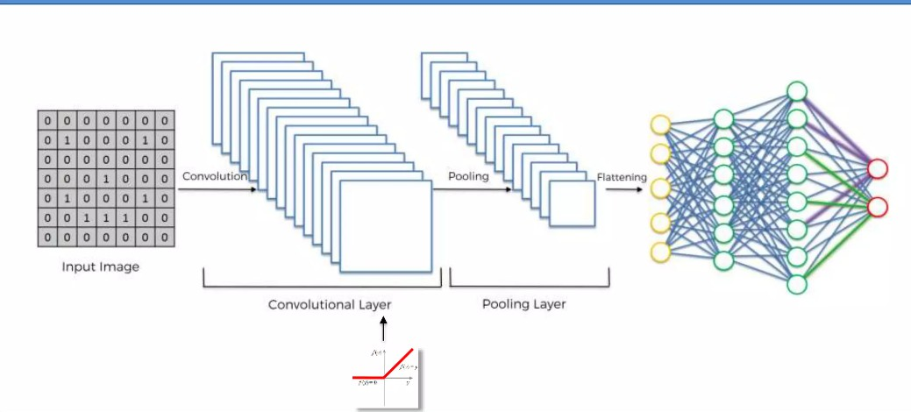

CONCLUSION
In conclusion, our study demonstrates the feasibility of using computer vision and machine learning algorithms to accurately identify medicinal plants with [X% accuracy]. This technology offers a promising approach for promoting sustainable harvesting practices, safeguarding biodiversity, and supporting traditional medicine practitioners.

REFERENCES
- A Novel Computer Vision Model for Medicinal Plant Identification Using Log-Gabor Filters and Deep Learning Algorithms:
- Applying Deep Learning and Machine Learning Algorithms for The Identification of Medicinal Plant Leaves Based on Their Spectral Characteristics
- Medicinal Plants Detection Using ML & DL
Research Papers on Specific Models and Datasets:
- An AI Based Approach for Medicinal Plant Identification Using Deep CNN Based on Global Average Pooling
- (PDF) Medicinal Plant Identification in Real- Time Using Deep Learning Model
- Multi-Stage Convolutional Neural Network for Medicinal Plant Leaf Classification

